Day 1

List of Programs:
1.The intervals and corresponding frequencies are as follows. age frequency
1-5. 200
5-15 450
15-20 300
20-50 1500
50-80 700
80-110 44
Compute an approximate median value for the data
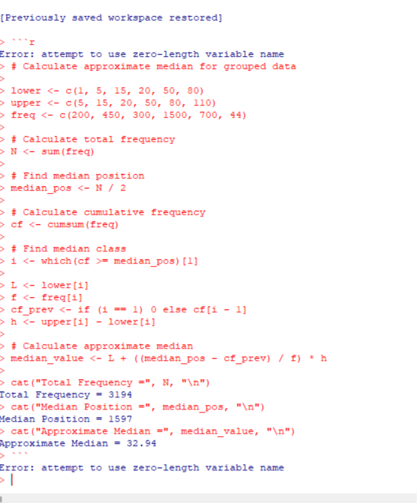

2.Suppose that the data for analysis includes the attribute age. The age values for the data
tuples are (in increasing order) 13, 15, 16, 16, 19, 20, 20, 21, 22, 22, 25, 25, 25, 25, 30, 33,
33, 35, 35, 35, 35, 36, 40, 45, 46, 52, 70.
(a) What is the mean of the data? What is the median?
(b) What is the mode of the data? Comment on the data’s modality (i.e., bimodal, trimodal,
etc.).
(c) What is the midrange of the data?
(d) Can you find (roughly) the first quartile (Q1) and the third quartile (Q3) of the data?
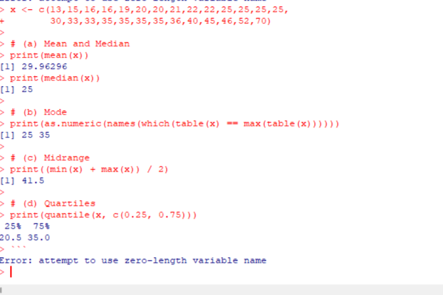
3.Data Preprocessing : Reduction and Transformation
Use the two methods below to normalize the following group of data: 200, 300, 400, 600,
1000 (a) min-max normalization by setting min = 0 and max = 1 (b) z-score normalization
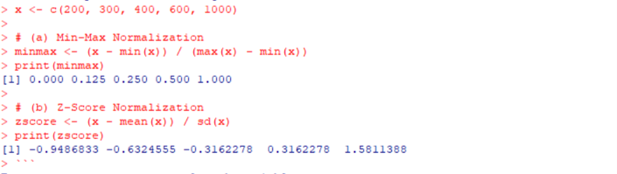
4.Data:11,13,13,15,15,16,19,20,20,20,21,21,22,23,24,30,40,45,45,45,71,
72,73,75
a) Smoothing by bin mean
b) Smoothing by bin median
c) Smoothing by bin boundaries
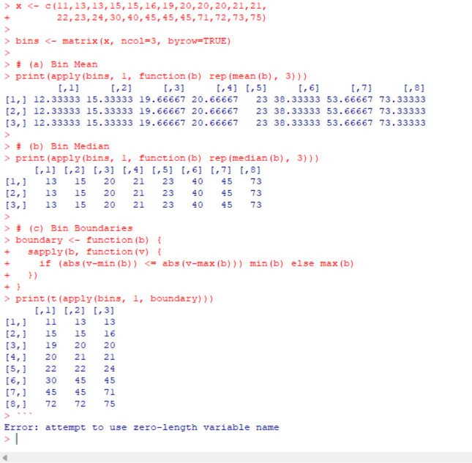
5. Suppose that a hospital tested the age and body fat data for 18 randomly selected adults
with the following results:
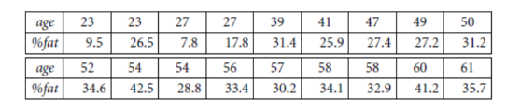
(a) Calculate the mean, median, and standard deviation of age and %fat.
(b) Draw the boxplots for age and %fat.
(c) Draw a scatter plot and a q-q plot based on these two variables.
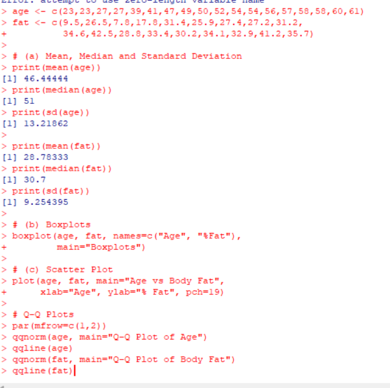
6.Suppose that a hospital tested the age and body fat data for 18 randomly selected adults
with the following results:
(i) Use min-max normalization to transform the value 35 for age onto the range [0.0, 1.0].
(ii) Use z-score normalization to transform the value 35 for age, where the standard
deviation of age is 12.94 years.
(iii) Use normalization by decimal scaling to transform the value 35 for age. Perform the
above functions using R – tool
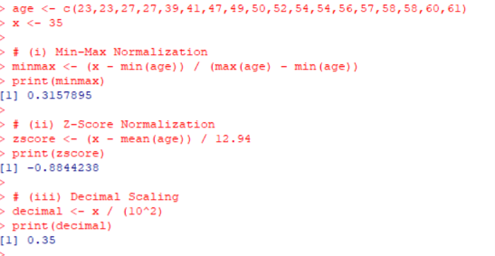
7.The following values are the number of pencils available in the different boxes. Create a
vector and find out the mean, median and mode values of set of pencils in the given data.
Box1 Box2 Box3 Box4 Box5 Box6 Box7 Box8 Box9 Box 10
9 25 23 12 11 6 7 8 9 10
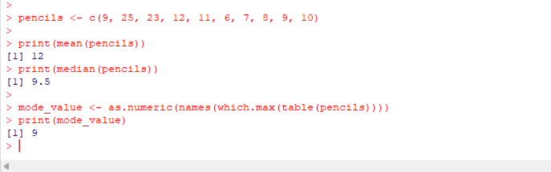
8. the following table would be plotted as (x,y) points, with the first column being the x
values as number of mobile phones sold and the second column being the y values as money.
To use the scatter plot for how many mobile phones sold.
x :4 1 5 7 10 2 50 25 90 36
y :12 5 13 19 31 7 153 72 275 110
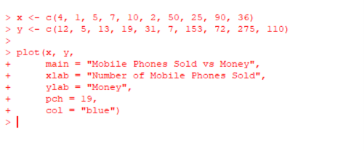
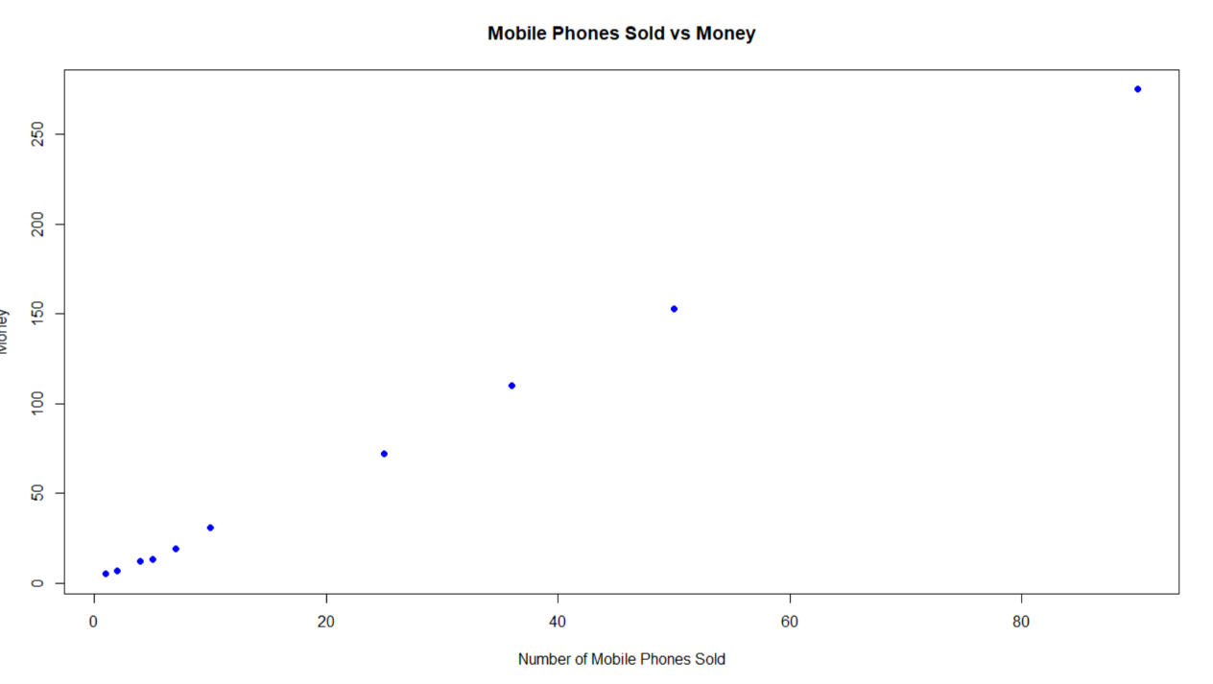
9. Implement of the R script using marks scored by a student in his model exam has been
sorted as follows: 55, 60, 71, 63, 55, 65, 50, 55,58,59,61,63,65,67,71,72,75. Partition them
into three bins by each of the following methods. Plot the data points using histogram.
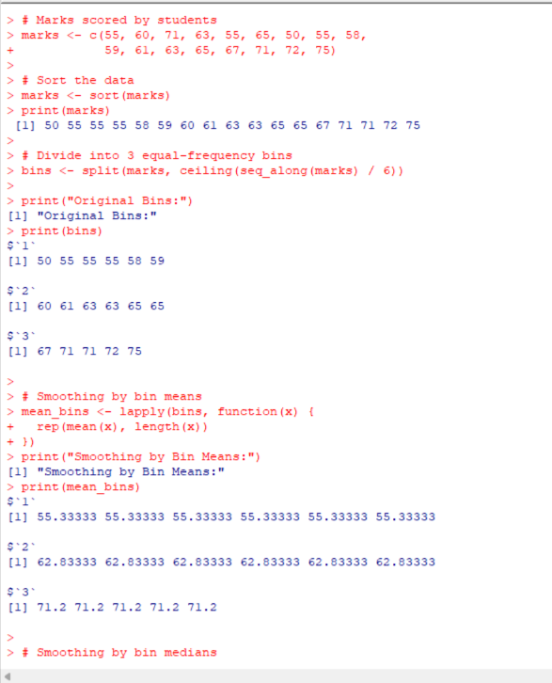
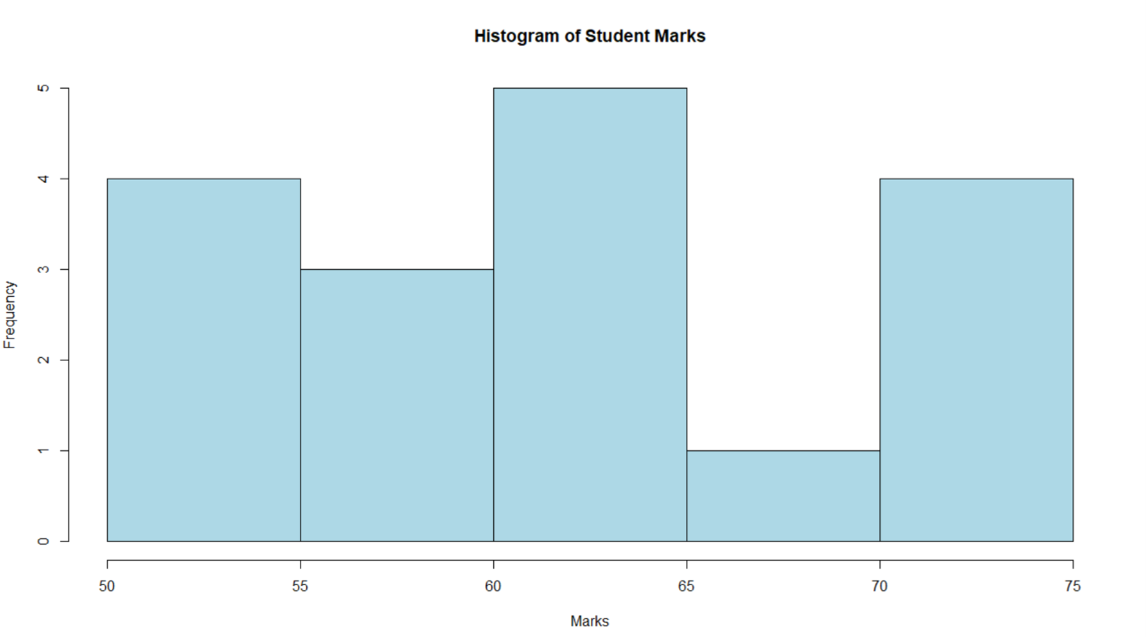
10. Suppose that the speed car is mentioned in different driving style.
Regular 78.3 81.8 82 74.2 83.4 84.5 82.9 77.5 80.9 70.6 Speed
Calculate the Inter quantile and standard deviation of the given data.
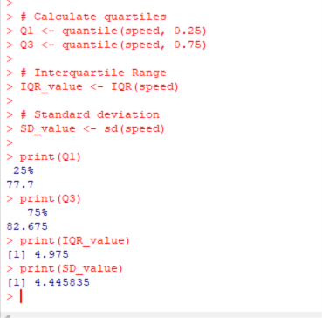
11.Suppose that the data for analysis includes the attribute age. The age values for
the data tuples are (in increasing order) 13, 15, 16, 16, 19, 20, 20, 21, 22, 22, 25,
25, 25, 25, 30, 33, 33, 35, 35, 35, 35, 36, 40, 45, 46, 52, 70.
Can you find (roughly) the first quartile (Q1) and the third quartile (Q3) of
the data?
